 | Practice Assignment – Quarter …, 20…-20…  Course Name: Backend Development  Course Code: CSW 306  Student’s Full Name:  Student ID:
Practice Assignment 6

CHAT APPLICATION
Continuing from the previous lab exercises, the library system now wants to integrate an additional chat channel with readers and create an environment for readers to interact with each other. Please help the library implement this requirement based on the following descriptions:

LEARNING OBJECTIVES:
- Understand and configure SignalR in ASP.NET Core
- Build a realtime chat app (broadcast → group → private)
- Save message history to SQL Server database
- Separate processing layers (Hub – Service – Model – Repository)

Exercise 1: Create a basic real-time chat application (Broadcast)
Requirements:
- Create an ASP.NET Core Web API project.
- Integrate a SignalR Hub (ChatHub) with a method SendMessage(string user, string message).
- Create a Razor View or MVC View to connect to the Hub for sending and receiving messages in real-time.
- Messages sent from one client should appear on all connected clients.
Objective: Understand the Hub–Client communication and broadcast messaging with SignalR.

Exercise 2: Add group chat functionality
Requirements:
- Create an API endpoint allowing clients to join or leave a room (JoinRoom, LeaveRoom).
- Hub should have a method SendGroupMessage(string roomName, string user, string message).
- Razor View should display a list of rooms and allow users to send messages within each room.
Objective: Practice SignalR Groups and integrating API with UI for room management.

Exercise 3: Add private chat functionality
Requirements:
- Create an API to manage a list of online users (username + connectionId).
- Hub should support SendPrivateMessage(string receiverConnectionId, string user, string message).
- Razor View or a separate view should allow selecting a recipient for private messages.
Objective: Implement private messaging via SignalR, combined with API + View.

Exercise 4: Store chat history in SQL Server (EF Core)
Requirements:
- Design a sample database:
Example table Messages
Field | Type | Description
Id | INT PK | Primary key
SenderId | INT FK | Sender
ReceiverId | INT FK NULL | Receiver, NULL if broadcast/group
RoomName | NVARCHAR(50) NULL | Room name if group
MessageBody | NVARCHAR(MAX) | Message content
MessageType | TINYINT | 0=broadcast,1=group,2=private
CreatedAt | DATETIME | Timestamp
- Use EF Core to store messages sent via the Hub.
- Create an API to fetch chat history and display it in the view when the page loads.
Objective: Learn how to combine SignalR + EF Core + SQL Server + API.

Exercise 5: Advanced – Complete the application
Requirements:
- Add authentication for users (Identity or token) to connect to the Hub.
- Display chat history by room or user in the view.
- Show notifications when users join/leave rooms in real-time.
- Optimize architecture: separate Service and Repository layers for API and Hub.
- Log messages to a file or HistoryLog table in the database.
Objective: Apply best practices in building a real-time chat application on API + View.
Advantages of this approach:
- Students practice both API development (endpoints, CRUD, authentication) and SignalR real-time features.
- Views can be integrated within the same project or built separately to call the API + Hub.
- Prepares students for real-world scenarios: Web API + SPA or MVC front-end.
Some suggestions for completing the assignment
(Important note: this is for reference only. To build a complete chat application, you need to apply your own programming thinking and rely on the knowledge you have learned.)
- For group chat, there is no need to store chat groups Id or members in the group into the database; a chat group is created when users connect to the hub and will be deleted after leaving the hub.
- Package need:
  - dotnet add package Microsoft.AspNetCore.SignalR
  - dotnet add package Microsoft.EntityFrameworkCore.SqlServer
  - dotnet add package Microsoft.EntityFrameworkCore.Tools
  - dotnet add package Microsoft.AspNetCore.Authentication.JwtBearer
- Create chatHub
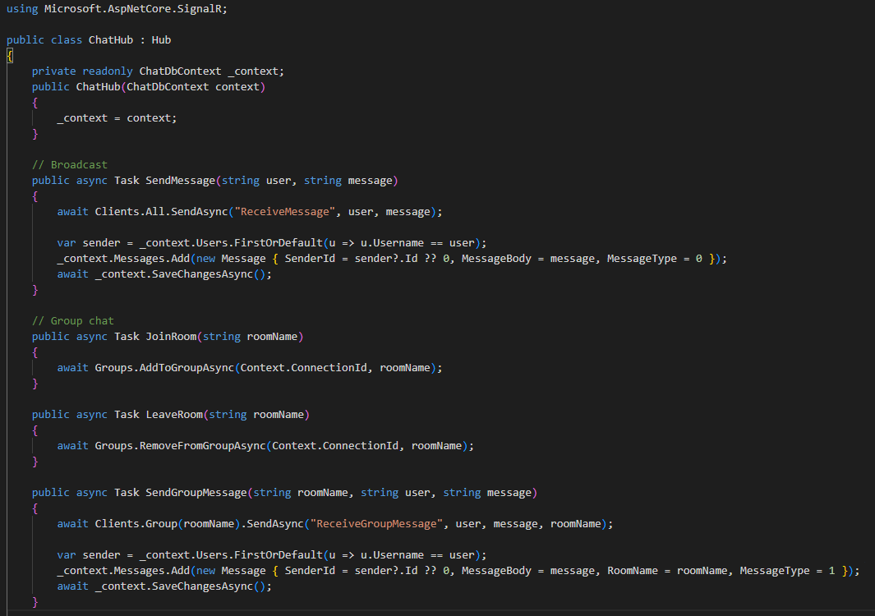
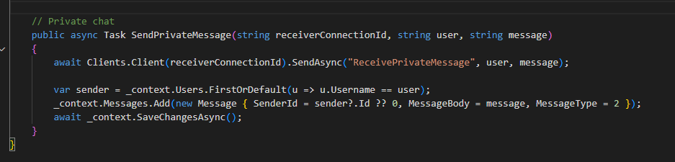
- Program.cs
builder.Services.AddSignalR();
app.MapHub<ChatHub>("/chathub");

- Razor View
Views/Chat/Index.cshtml: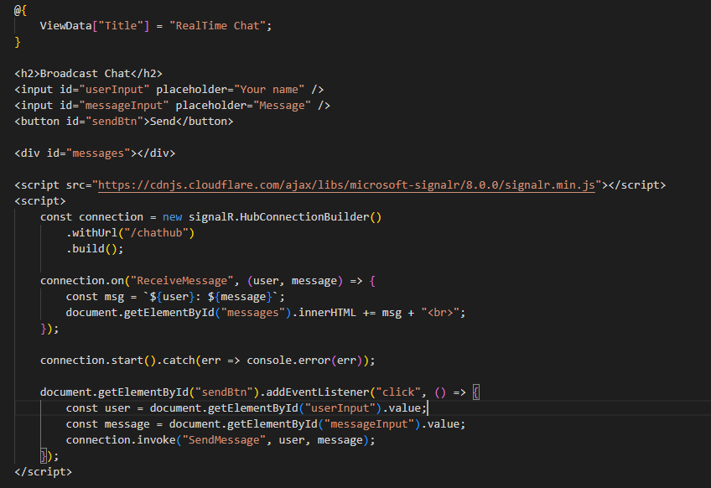
Similarly, create views for both group chat and private chat
- API endpoints (Optional)
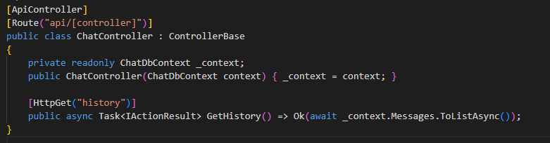
Used to load message history on view.
- Authentication (JWT Example)
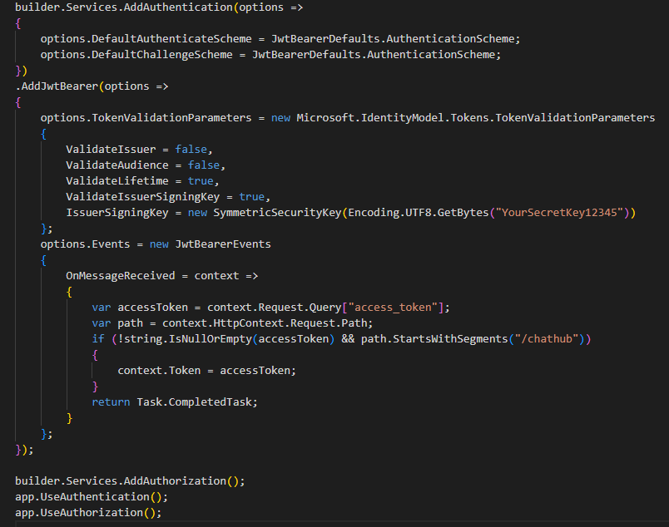
Use JWT or Identity. When client connects to hub, send token:
Hub has [Authorize] on class or method.

